# Basic Of Web Programming

# Lab-4

1-Design vertical navigation bar like following

Code:

<!DOCTYPE html>

<html lang="en">

<head>

<meta charset="UTF-8">

<title>1</title>

<style>

a{

text-decoration: none;

color: white;

}

li{

margin-top: 10px;

padding: 10px;

}

li:hover{

background: white;

color: black;

cursor: pointer;

}

li:hover a{

color: black;

}

</style>

</head>

<body>

<nav>

<ul style="list-style: none;background-color: green;color: white;width: 100px;padding: 30px;">

<li><a href="">HOME</a></li>

<li><a href="">NEWS</a></li>

<li><a href="">CONTACT</a></li>

<li><a href="">ABOUT</a></li>

</ul>

</nav>

</body>

</html>

Output:

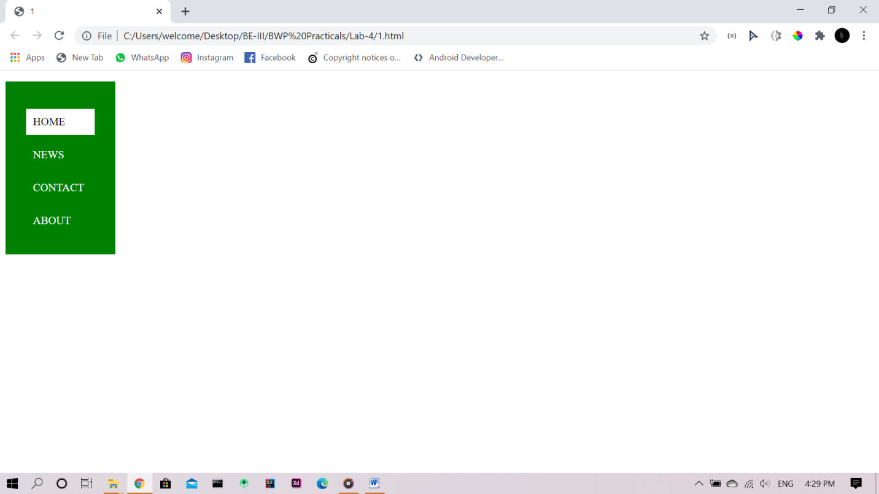

2: Design horizontal navigation bar like following

Code:

<!DOCTYPE html>

<html lang="en">

<head>

<meta charset="UTF-8">

<title>2</title>

<style>

ul{

position: absolute;top: 50%;left: 50%;transform: translate(-50%,-50%);

}

ul,li{

margin: 0;

margin-right: 40px;

padding : 20px;

float: left;

}

a{

text-decoration:none;

color: white;

}

li:hover{

background:white;

}

li:hover a{

color: black;

}

</style>

</head>

<body>

<nav style="background-color: green;width: 100%;height: 100px;position: relative;">

<ul style="list-style: none;">

<li><a href="">HOME</a></li>

<li><a href="">NEWS</a></li>

<li><a href="">CONTACT</a></li>

<li><a href="">ABOUT</a></li>

</ul>

</nav>

</body>

</html>

Output:

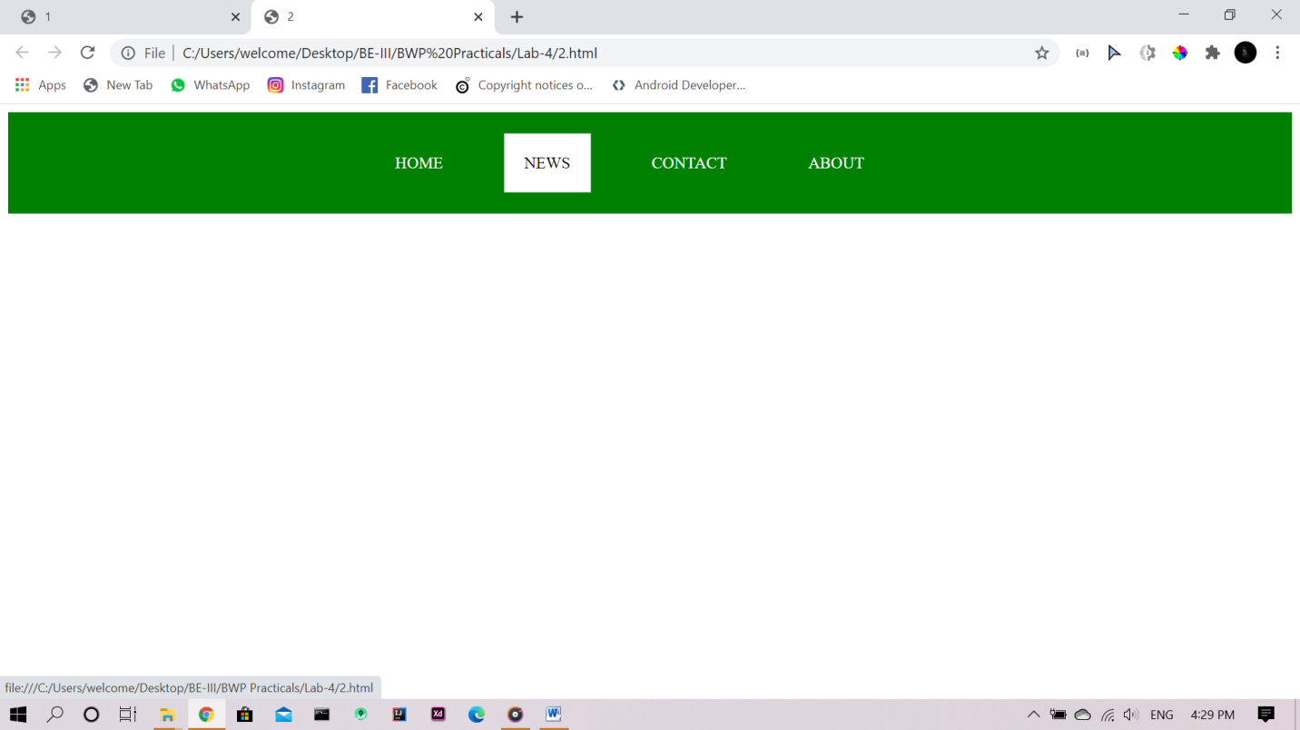

3Design web page like following

Code:

<!DOCTYPE html>

<html lang="en">

<head>

<meta charset="UTF-8">

<title>3</title>

</head>

<body style="margin: 0;padding: 0; background-image: url(images.jpg);">

<div style="width: 80%;height: 300px;background-color: white; position: absolute;top: 50%;left: 50%;transform: translate(-50%,-50%);opacity: 0.5;border: 5px solid black;">

<span style="position: absolute;top: 50%;left: 50%;transform: translate(-50%,-50%);font-weight: bolder;color: black;">This is Some Text that is placed in the transperent box.This is Some Text that is placed in the transperent box.This is Some Text that is placed in the transperent box.This is Some Text that is placed in the transperent box.This is Some Text that is placed in the transperent box.This is Some Text that is placed in the transperent box.This is Some Text that is placed in the transperent box.This is Some Text that is placed in the transperent box.</span>

</div>

</body>

</html>

Output:

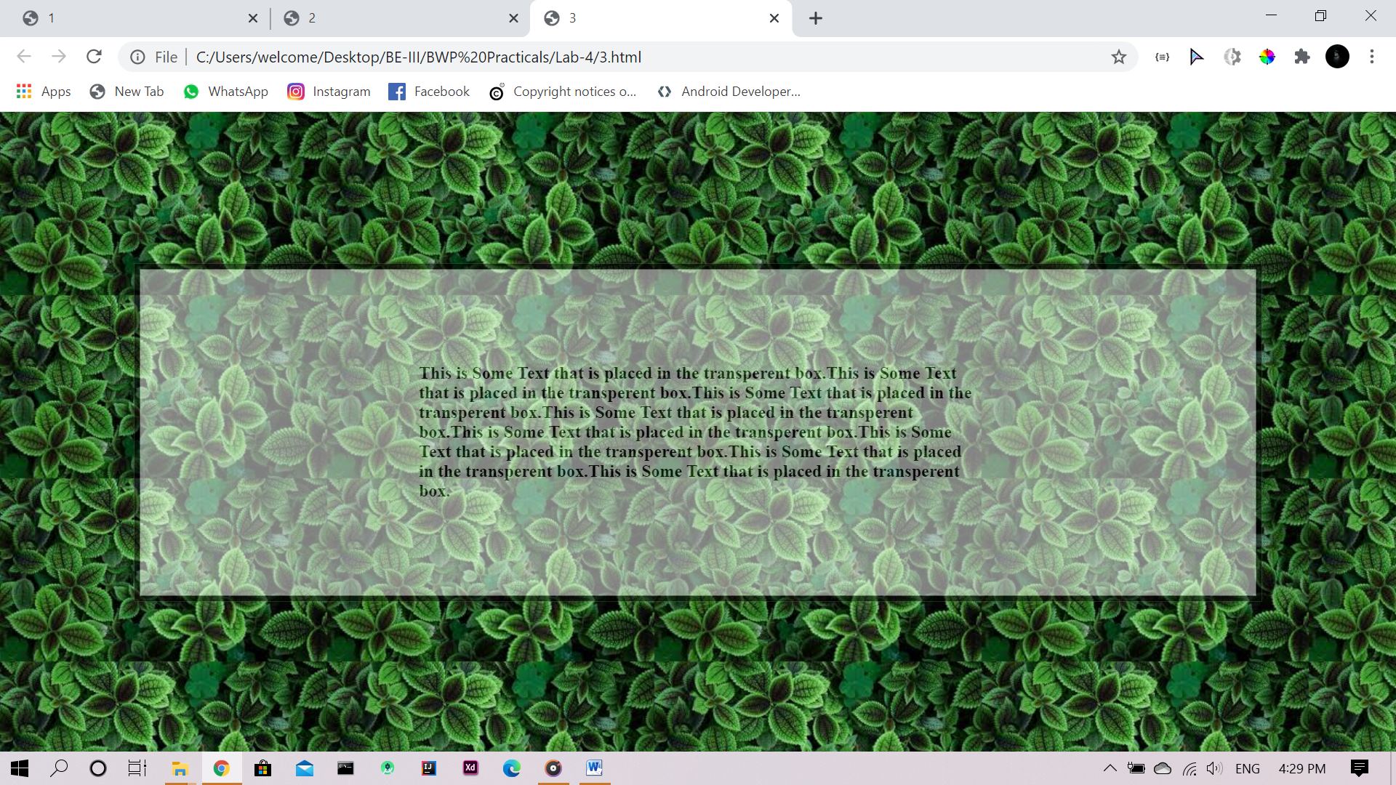

4: Design a web page in which list has difference style

Code:

<!DOCTYPE html>

<html lang="en">

<head>

<meta charset="UTF-8">

<title>4</title>

</head>

<body>

<p>Example of unordered list</p>

<ul style="list-style-type: circle;">

<li>Coffee</li>

<li>Tea</li>

<li>Coca-cola</li>

</ul>

<ul style="list-style-type: square;">

<li>Coffee</li>

<li>Tea</li>

<li>Coca-cola</li>

</ul>

<p>Example of ordered list</p>

<ol style="list-style-type: upper-roman;">

<li>Coffee</li>

<li>Tea</li>

<li>Coca-cola</li>

</ol>

<ol style="list-style-type:lower-alpha;">

<li>Coffee</li>

<li>Tea</li>

<li>Coca-cola</li>

</ol>

</body>

</html>

Output:

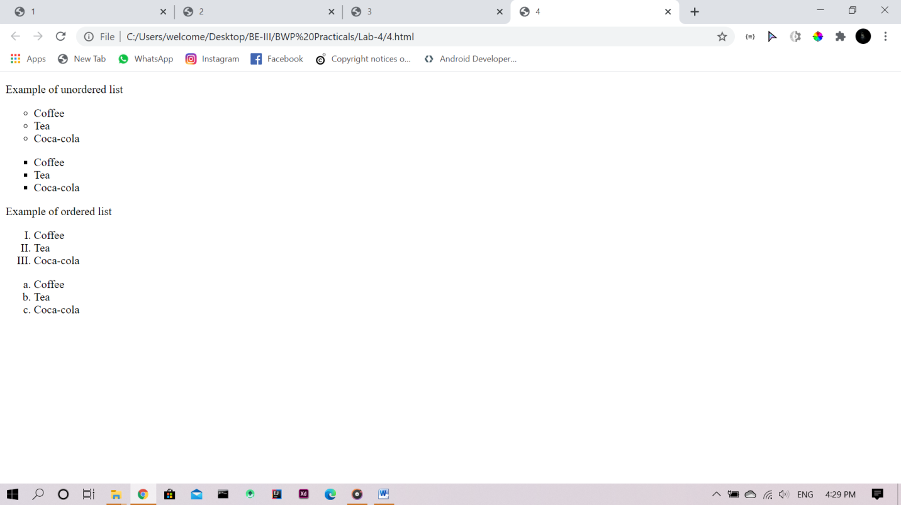

5: Design a web page in which element float around another element.

Code:

<!DOCTYPE html>

<html lang="en">

<head>

<meta charset="UTF-8">

<title>5</title>

<style>

img{

width: 100px;

margin: 10px;

float: left;

}

</style>

</head>

<body>

<h1>Image Gallary</h1>

<p>Try resizing the window to see what happen when images have not inough space.</p>

<img src="images.jpg" alt="">

<img src="images.jpg" alt="">

<img src="images.jpg" alt="">

<img src="images.jpg" alt="">

<img src="images.jpg" alt="">

<img src="images.jpg" alt="">

<img src="images.jpg" alt="">

<img src="images.jpg" alt="">

</body>

</html>

Output:

